Kleurenpalet website TN

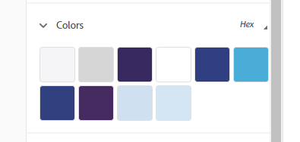

#F5F4F7  #00000029  #372860  #FFFFFF  #2E3E84  #45ACD9  [actie buttons] |  | #303F7F  #462B61  #CEE1F2  #D4E5F5

